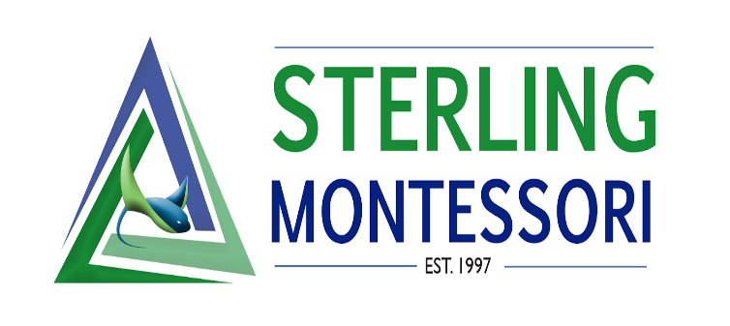

Executive Director Board Report- October

School News
- Academy update: 123/128 contracts and deposits are in for academy students.
- Charter update: 623 enrolled, 5 offers out
- Mini Fall break camp registration is closed and we have 9 students enrolled in elementary and 23 enrolled in children’s house.
Staff News
- Professional development for October:
  - Working session from home for all Directors and teaching staff on the PD day (October 18th) on Social Emotional Learning. Staff were provided with videos to watch and reading totaling 6 hours of training due by December and a requirement for DPI.
  - Parent Conferences held on October 19th.
  - Weekly section meetings continue to focus on curriculum lesson studies meeting state standards and AMS standards.
Administration News
- ESSER III application has been resubmitted and approved. ESSER III funds- 20% required to be used for learning loss. The 20% will go toward intervention materials and learning materials for EC, reading and math specialist and anything else needed in the classrooms not purchased from the ESSER II funds. The remainder 80% will be used for outdoor educational environments- picnic tables, shade sails and furniture. Team representatives have collected classroom needs to purchase outdoor furniture.
- Current consultants working with teams on AMS accreditation standards: EC/Montessori consultant observing and consulting on schedules and inclusion, Children’s House consultant working with the CH team observing and to provide Montessori resources, middle school math teachers working with a consultant to establish MS math curriculum and structure. Still searching for an elementary consultant to work with the team.
- Interviews for administration assistant and classroom assistant.
- Calendar – 3 options for Sterling based on Wake County start date- staff voted for calendar #1. (See below).

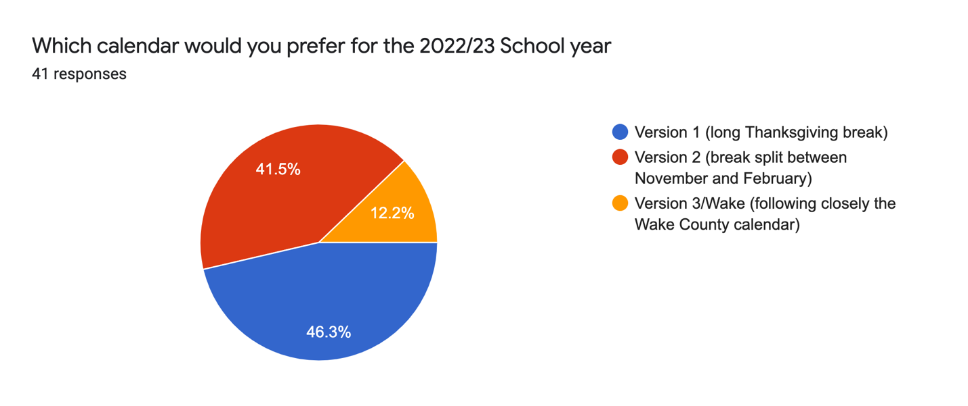

COVID Reporting
- Reporting in weekly messages every Friday. None reported at this time.

