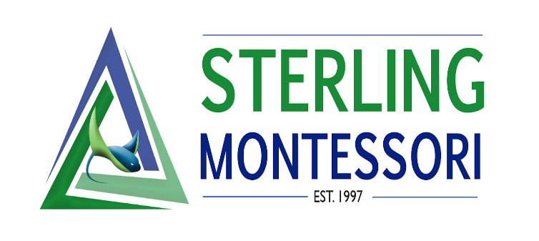

Executive Director Board Report- November

School News
- Academy update: 128/128 contracts and deposits are in for academy students.
- Charter update: 623 enrolled
- Preparations for spring break camp and summer camp in progress
- With COVID funds, purchasing of new reading, science and math materials to streamline classrooms in CH, LE, and UE.
- Student Ambassadors coordinated a peace tree ceremony with all LE, UE, and MS students with the planting of a tree and classroom rocks.
- Advertisement for Sterling Academy in the Morrisville Chamber of Commerce Map & Resource Guide.

Staff News
- Dipti Dhungel resigned from beforecare effective November 29th. Becki Peterson will take on beforecare.
- Danielle Lamb has resigned effective December 1st. Posting to be placed soon.
- Professional development for November:
  - Social Emotional Learning. Staff were provided with videos to watch and reading totaling 6 hours of training due by December and to be discussed in section meetings in January.
  - Weekly section meetings continue to focus on curriculum lesson studies meeting state standards and AMS standards.
  - Teacher trainer meetings with some directors to provide support for teachers in Montessori training.
  - Consultant meeting with teams to discuss goals to be an inclusive school. Professional Development to be provided in January.
  - Counselor and Director support and resources for all teachers on zones of regulation.

Administration News
- Interviews for current positions
- Transitional duties within administration in progress
- Reporting
- Current consultant working with the MTSS core team for an inclusion model for support

