Development Committee Update 2021/22

Thursday, September 9, 2021
- ESSER III funds (~$197k) to be used for outdoor environments - leading drive for Development focus
  - Parent Survey of needs/wants - Review what was asked previously from families
  - Team Rep questions (to poll classes/levels for outdoor needs) - Josie met with them on Tuesday, Sept 7
    - What type of outdoor improvement would you like to have near your classroom?
    - How would this improvement be incorporated into Montessori education for your students?
    - What feature would you like added to Sterling in any outdoor environment?
    - How can you imagine this feature/improvement enhancing the student’s Montessori experience?
  - LE/UE/MS Student requests - present at Student Council and have them follow up. Assigned to Justin/Carrie to discuss at the first meeting (Oct 1)
- From the above feedback, we can create a story about our goals for 2021/22. This can then be taken to businesses - creating a “Package” with the plan for this year, and the Annual Report from last year
- Charleston Wrap virtual fundraiser to run the next two weeks. Information has been distributed to classrooms with the class goals. Jenn Jewett is charing
- Meeting with Morrisville Chamber of Commerce - in person - on Tuesday, September 14th for Meet & Coffee (first in-person in a long time)
- Need to have 100% Board participation - only ⅓ of directors have contributed. Again, this makes for a compelling argument. The same would be true for Administration, at the very least.
- Grandparents and Sponsor campaign “Growing into our Future”?? In addition to our compelling story - would love involvement in generating ideas to hook grandparents
  - Have pulled information from Infosnap - need to import it into Little Green Light
  - Worth doing a digital and snail mail campaign/postcards?
- Reminder of our Development Buckets and current totals
  - Development Account - currently at $17,734.55 ($16,424.12 was “rollover” from previous year)
  - 21/22 Annual Fund collections (since July 1) - $3,491.96
  - All money out to date has been for PFSA - Spirit Wear, Movie Night licenses, Yearbook (2020/21) and we paid for $350 for the compasses for PE with the grant we won last year.
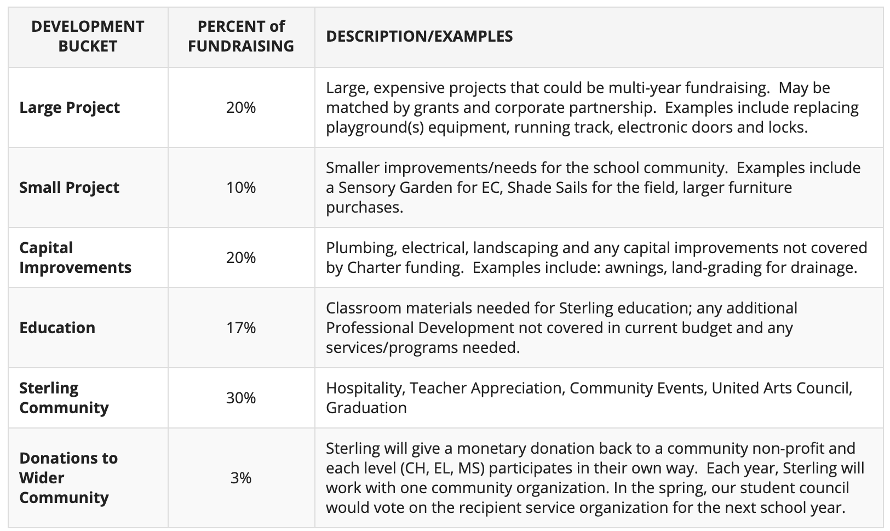

Annual Fund 2021/22 Calendar/Timeline

