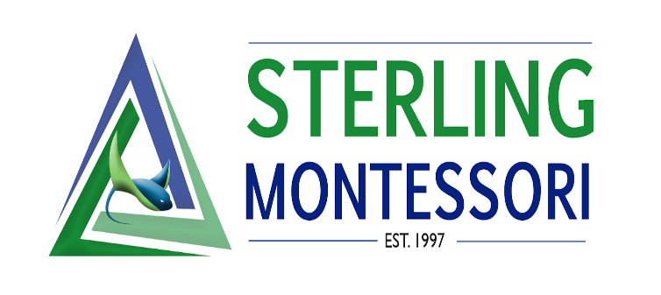

Executive Director Board Report- January

School News
- Academy update: 128/128 contracts for the 2021/2022 school year and 39 applications in for the 2022/2023 school year.
- Charter update: 618/624 enrolled. Over 800 applications for the 2022/2023 school year.
- Community Coffee Chat on Assessment led by the directors- over 70 parents

Staff News
- January 3rd Professional Development on being an Inclusive School – Christine Lowry provided a teacher training.

Administration News
- Beginning Teacher Support Program (BTSP) Audit
- Director meetings with Inclusion/Montessori Consultant Christine Lowry
- Josie met with Peaceful Schools -consultation would include looking at Sterling’s DEI plan, goals, and work so far as a committee/school. They charge $ 350 per contact hour
Waiting to hear back from them to see if they will meet with directors.

