Meeting Minutes
LHU Board of Directors Special Meeting January 12, 2022
Sterling Montessori Academy and Charter School 7:00 PM 202 Treybrooke Drive, Morrisville, NC 27560 Virtual via Google Meet

Board Member Attendance:
Name | Present |  | Name | Present |  | Name | Present
Steve Mansbery |  |  | Wallace Lewis | x |  | Rachel Richardson | x
Kim Elliott | x |  | Elizabeth Uzzell | x |  | Leslie Hamilton | x
Ryan Hill | x |  | Kari Schwab | x |  | Lan Zhu | x
Chris Morton | x |  | Robert Wolfe | x |  | Katie Brown

Additional Attendees:

7:10 PM Call to Order: Meeting called to order by Elizabeth Uzzell.

Reading of Mission Statement:
“The mission of Sterling Montessori is to create a diverse educational community, grounded in the Montessori philosophy and teaching practices, that fosters curiosity, creativity, and critical thinking in its students. We strive to empower each student to become life-long learners who respect themselves, others, and their environment.”

Welcome Attendees

Agenda Items:
- Approval of Hires
- Staff Bonus Details and COVID Funds
- Review and approve updates to the Teacher’s Assistant pay scale
- Closed Session for personnel discussion

Consent Item – Approval of Agenda
At 7:11p, Elizabeth Uzzell moved to approve the agenda with additions discussed. Rachel Richardson second to approve the agenda. Approved

Name | Aye | Nay | Abs |  | Name | Aye | Nay | Abs |  | Name | Aye | Nay | Abs
Steve Mansbery |  |  |  |  | Wallace Lewis | x |  |  |  | Rachel Richardson | 2
Kim Elliott | x |  |  |  | Elizabeth Uzzell | M |  |  |  | Leslie Hamilton | x
Ryan Hill | x |  |  |  | Kari Schwab | x |  |  |  | Lan Zhu | x
Chris Morton | x |  |  |  | Robert Wolfe | x |  |  |  | Katie Brown

7:11 PM Discussion Items
Approval of Hires - Presentation by Josie
- Nicole Pratt background
- Candice Devito background
Staff Bonus Details and COVID Funds
Review and approve updates to the Teacher’s Assistant pay scale

Consent Item – Approval of Hire Upper Elementary Assistant
At 7:12p, Elizabeth Uzzell moved to approve the hire of Nicole Pratt as Upper Elementary Assistant at step 9 on the Sterling Montessori assistant pay scale Lan Zhu as a second. Approved

Name | Aye | Nay | Abs |  | Name | Aye | Nay | Abs |  | Name | Aye | Nay | Abs
Steve Mansbery |  |  |  |  | Wallace Lewis | x |  |  |  | Rachel Richardson | x
Kim Elliott | x |  |  |  | Elizabeth Uzzell | M |  |  |  | Leslie Hamilton | x
Ryan Hill | x |  |  |  | Kari Schwab | x |  |  |  | Lan Zhu | 2
Chris Morton | x |  |  |  | Robert Wolfe | x |  |  |  | Katie Brown

Consent Item – Approval of Hire Children’s House Assistant
At 7:15p, Elizabeth Uzzell moved to approve the hire of Candice Devito as Children’s House Assistant at step 21 on the Sterling Montessori assistant pay scale. Wallace Lewis as second. Approved

Name | Aye | Nay | Abs |  | Name | Aye | Nay | Abs |  | Name | Aye | Nay | Abs
Steve Mansbery |  |  |  |  | Wallace Lewis | 2 |  |  |  | Rachel Richardson | x
Kim Elliott | x |  |  |  | Elizabeth Uzzell | M |  |  |  | Leslie Hamilton | x
Ryan Hill | x |  |  |  | Kari Schwab | x |  |  |  | Lan Zhu | x
Chris Morton | x |  |  |  | Robert Wolfe | x |  |  |  | Katie Brown

Bonus Review - State Recovery Funds
[From Betty Warren]
Sterling is receiving funds for 3 different bonuses which are all due to be paid by January 31st.

1) Funds from the State Fiscal Recovery Funds - PRC 141
This bonus provides $1,000 for all employees and an additional $500 for all employees who make less than $75,000 per year. This is the bonus which was discussed in the last finance meeting and it was agreed that all employees would receive the total $1,500 in addition to paying $1,500 to 3 contracted employees. DPI will fund us a total of $139K and the school will provide $8K.

2) Funds from the State for Teacher Legislated Bonus - PRC 036
This bonus provides $300 to each state funded teacher and instructional support personnel, which includes 40 of our staff. DPI has fully funded this bonus in the amount of $13K.

3) Funds from ESSER III Employee Bonuses - PRC 203
This bonus provides $1,000 to each qualifying teacher and instructional support staff which includes 40 employees. DPI has funded us a total $34K which will pay for 32 positions. The other 8 will need to be funded by Sterling and this will require an additional $9K. DPI has acknowledged that there could be a shortfall in funding and they have given us the option to recode existing ESSER funds in order to pay this differential.

Also, DPI has given schools the option to pay this bonus to all employees and to use existing ESSER funds to supplement this. Sterling has a balance remaining in PRC 182 of $167K. I have discussed this with Josie and she would like for finance to consider paying this bonus to all employees at Sterling. If finance agrees to this, then a total of $60K of the PRC 182 funds will be used. This bonus will not include contracted employees.

An application and budget must be submitted to DPI in order to receive the PRC 203 funds. Also, a budget amendment will need to be submitted for PRC 182. We will need to make a decision at the finance meeting on the PRC 203 bonus.
Discussion:
PRC 182 - we had it approved for specifically outdoor equipment and spent about $80k-90k with $167k estimated remaining. Because it is being reallocated - we can do and are required to document this accordingly. This reallocation will change expectations for outdoor equipment/furniture; however, little concern around response to this shift.
Noting items above:
#1: Has previously been approved and announced.
#2: Notes 40 staff - Lead teachers and some additional support staff
#3: Reallocating $60k of ESSER III funds from PRC 182 to PRC 203

Teacher Assistant Scale
Adjusting to matching the Wake County Scale will impact our budget at about $200k.

Consent Item – Approval of Bonus Funds
At 7:35p, Kim Elliott moved to approve reallocating ESSER III funds of $60,000 of PRC 182 to, PRC 203 to supplement employee bonuses for all full time staff in accordance with DPI allowance. Robert Wolfe as second. Approved

Name | Aye | Nay | Abs |  | Name | Aye | Nay | Abs |  | Name | Aye | Nay | Abs
Steve Mansbery |  |  |  |  | Wallace Lewis | x |  |  |  | Rachel Richardson | x
Kim Elliott | M |  |  |  | Elizabeth Uzzell | x |  |  |  | Leslie Hamilton | x
Ryan Hill | x |  |  |  | Kari Schwab | x |  |  |  | Lan Zhu | x
Chris Morton | x |  |  |  | Robert Wolfe | 2 |  |  |  | Katie Brown | x

Consent Item – Approval of Bonus Funds
At 7:37p, Kim Elliott moved to approve allocation of $3,000 for one time bonus to three contracted employees to be paid with employee bonus’ from ESSER III funds. Robert Wolfe as second. Approved

Name | Aye | Nay | Abs |  | Name | Aye | Nay | Abs |  | Name | Aye | Nay | Abs
Steve Mansbery |  |  |  |  | Wallace Lewis | x |  |  |  | Rachel Richardson | x
Kim Elliott | M |  |  |  | Elizabeth Uzzell | x |  |  |  | Leslie Hamilton | x
Ryan Hill | x |  |  |  | Kari Schwab | x |  |  |  | Lan Zhu | x
Chris Morton | x |  |  |  | Robert Wolfe | 2 |  |  |  | Katie Brown | x

Consent Item – Approval of updates to Teacher’s Assistant Scale
At 7:42p, Kim Elliott moved to approve the update to the Teacher’s Assistant pay scale to match the Wake County 2021-2022 Teacher Assistant pay scale effective immediately with an estimated impact of $200,000 and an adjustment to the Associate Teacher pay scale. Elizabeth Uzzell as second. Approved

Name | Aye | Nay | Abs |  | Name | Aye | Nay | Abs |  | Name | Aye | Nay | Abs
Steve Mansbery |  |  |  |  | Wallace Lewis | x |  |  |  | Rachel Richardson | x
Kim Elliott | M |  |  |  | Elizabeth Uzzell | 2 |  |  |  | Leslie Hamilton | x
Ryan Hill | x |  |  |  | Kari Schwab | x |  |  |  | Lan Zhu | x
Chris Morton | x |  |  |  | Robert Wolfe | x |  |  |  | Katie Brown | x

Consent Item – Approval of Additional Floater
At 7:57p, Elizabeth Uzzell moved to create the position of an additional floater/support staff to be filled by Denise Tucker effective immediately on step 9 of Teacher Assistant. Wallace Lewis as second. Approved

Name | Aye | Nay | Abs |  | Name | Aye | Nay | Abs |  | Name | Aye | Nay | Abs
Steve Mansbery |  |  |  |  | Wallace Lewis | 2 |  |  |  | Rachel Richardson | x
Kim Elliott | x |  |  |  | Elizabeth Uzzell | M |  |  |  | Leslie Hamilton | x
Ryan Hill | x |  |  |  | Kari Schwab | x |  |  |  | Lan Zhu | x
Chris Morton | x |  |  |  | Robert Wolfe | x |  |  |  | Katie Brown | x

8:00 PM Enter Closed Session
At 8:01p, Elizabeth Uzzell moved to go into closed session pursuant NCGS 143-318.11(6) for discussion of personnel matters. Kari Schwab as second. Approved.

Name | Aye | Nay | Abs |  | Name | Aye | Nay | Abs |  | Name | Aye | Nay | Abs
Steve Mansbery |  |  |  |  | Wallace Lewis | x |  |  |  | Rachel Richardson | x
Kim Elliott | x |  |  |  | Elizabeth Uzzell | M |  |  |  | Leslie Hamilton | x
Ryan Hill | x |  |  |  | Kari Schwab | 2 |  |  |  | Lan Zhu | x
Chris Morton | x |  |  |  | Robert Wolfe | x |  |  |  | Katie Brown | x

8:29 PM Return to Open Session
At 8:29p, Elizabeth Uzzell moved to return to the open session. No action taken during the closed session. Kim Elliott as second. Approved.

Name | Aye | Nay | Abs |  | Name | Aye | Nay | Abs |  | Name | Aye | Nay | Abs
Steve Mansbery |  |  |  |  | Wallace Lewis | x |  |  |  | Rachel Richardson | x
Kim Elliott | 2 |  |  |  | Elizabeth Uzzell | M |  |  |  | Leslie Hamilton | x
Ryan Hill | x |  |  |  | Kari Schwab | x |  |  |  | Lan Zhu | x
Chris Morton | x |  |  |  | Robert Wolfe | x |  |  |  | Katie Brown | x

8:30 PM Adjournment
At 8:30p, Elizabeth Uzzell made a motion to adjourn. Chris as second. Approved.

Name | Aye | Nay | Abs |  | Name | Aye | Nay | Abs |  | Name | Aye | Nay | Abs
Steve Mansbery |  |  |  |  | Wallace Lewis | x |  |  |  | Rachel Richardson | x
Kim Elliott | x |  |  |  | Elizabeth Uzzell | M |  |  |  | Leslie Hamilton | x
Ryan Hill | x |  |  |  | Kari Schwab | x |  |  |  | Lan Zhu | x
Chris Morton | 2 |  |  |  | Robert Wolfe | x |  |  |  | Katie Brown | x

Attendance:
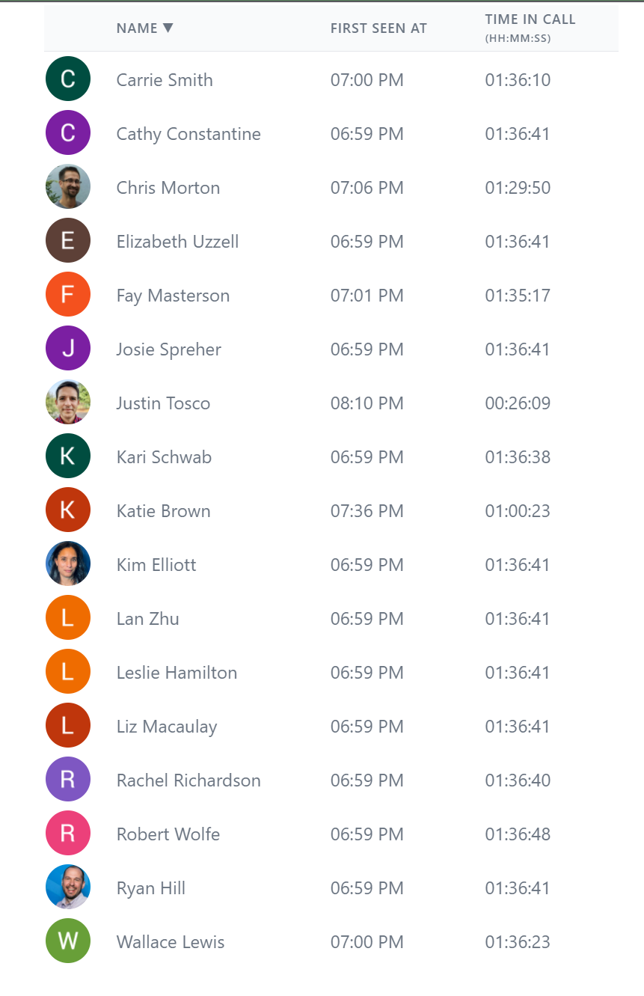
Respectfully submitted by Ryan Hill, LHU Secretary

