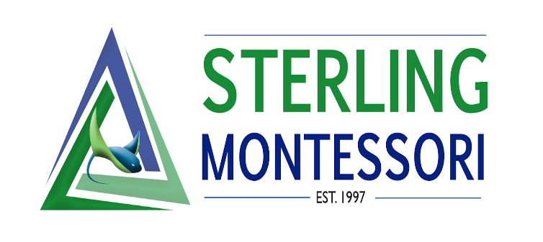

Executive Director Board Report- February

School News
- Academy update: 128/128 contracts for the 2021/2022 school year and 60 applications in for the 2022/2023 school year. February reenrollment for all current 3-year-old families sent out and due by the end of the month.
- Charter update: 617/624 enrolled in the 2021/2022 school year. About 1500 applications for the 2022/2023 school year and the lottery is closed.
- Preparing for spring break and summer camp information to go out and registrations

Staff News
- Art teacher Courtney’s last day will be on February 28th in order to take care of the health of her and the baby until May due date. She will not return for the fall. I have posted for the position and Carrie and I are interviewing candidates (we have several qualified candidates).
- Interviewing candidates for the MS math/science position and MS associate position.

Administration News
- Director meetings with Inclusion/Montessori Consultant Christine Lowry- Working on our MTSS framework.
- Rownak, Josie, and Christine met with DPI representatives about the inclusive model and compliance questions.
- Josie meets with consultant Christine Lowry once weekly. Currently I am working on: restructuring our EC department in order to work together as cohesive teams. The EC Director position will become an Inclusion/EC Coordinator (responsible for paperwork and compliance for DPI and works closely with directors and teachers for MTSS and EC support). EC teachers will become Inclusion/EC level teachers (each level will have a dedicated teacher assigned and will work with the director and teacher to establish goals for students in an inclusive setting). See job descriptions attached.
- Directors will be meeting with consultants from peaceful schools monthly to talk about schoolwide DEI goals and professional development.

COVID Protocol Updates
- Sterling will continue mask mandates until it is changed to optional in Strong Schools
- Strong Schools updates as of February 10, 2022 and effective February 21, 2022:
EXPOSED TO SOMEONE WITH COVID-19 WITHIN THE LAST 2 WEEKS
- Not vaccinated or have not received booster (if eligible)
  - As of February 21, 2022 exclusion from school for exposure only is no longer recommended
  - Complete 10 days of strict mask use and continue to watch for symptoms, with immediate testing if symptomatic.
- Vaccinated and eligible for a booster, but not yet been boosted
  - As of February 21, 2022 exclusion from school for exposure only is no longer recommended
  - Complete 10 days of strict mask use and continue to watch for symptoms, with immediate testing if symptomatic.
- Vaccinated, and have either received a booster or are not yet eligible for a booster
  - You do not need to be excluded from school (stay away from others)
  - Complete 10 days of strict mask use and continue to watch for symptoms, with immediate testing if symptomatic.
Following NCDHHS SafeSchool for Childcare, Children's House students must be excluded from school for 5 days after exposure. Students may return to school after exclusion if asymptomatic but must continue to wear a mask for an additional 5 days, for a total of 10 days after exposure. Students should test on day 5, if possible. If symptoms occur, students should immediately isolate until a test either confirms COVID-19, or a negative result rules it out. If the student cannot wear a mask for the remaining 5 days, including children under the age of 2, they must be excluded for 10 days after the day of last exposure.

