Development Committee Update 2021/22

Thursday, April 7, 2022

Updated 4/6/22 |  | $ 16,424.12 | Rolled Over Amount from 2020/21
 |  | $ 41,036 | Amount Raised in 2021/22 School Year
Fundraising "Buckets" | Est % of Dev Budget | $ 57,460 | '21/22 Actual Amt. Spent | '21/22 Actual % | Amount Remaining | Spending Description
Large Project | 20% | $ 11,492 |  | 0% | $ 11,492
Small Project | 10% | $ 5,746 | $ 5,283 | 31% | $ 463 | Based of MS Garden $3000 grant ($2935.10); MS Blinds ($2347.90)
Capital Improvements | 20% | $ 11,492 |  | 0% | $ 11,492
Education | 17% | $ 9,768 | $ 9,559 | 17% | $ 209 | Bus to Carowinds & Chestnut Ridge
Community Goodwill/Sterling Community | 30% | $ 17,238 | $ 8,995 | 16% | $ 8,243 | Sterling Spirit Wear, Garden Day, Teacher Appreciation; International Festival Expenses to date
Donations to external non-profit | 3% | $ 1,724 |  | 0% | $ 1,724
Totals | 100% | $ 57,460 | $ 23,837 |  | $ 33,623

- Recent Development additions:
  - $1545 raised from IF craft - over $1000 Spirit Wear
  - Over $700 raised from Garden Day (proceeds)
  - Book Fair deliveries completed; raised $981.43 (awaiting delivery of check)
- Looking to do one more “Why We Give” with the Sick Family (Michael and Janaee, son Miles) in May
- NLI/Outdoor Design
  - Met with alternate to NLI yesterday (Bieber Landscape) to get a different quote
  - Brad spent 7 years with NLI and his initial approach (Master design, input and education from the stakeholders, etc.) is on par with their approach
  - He admitted that what we would get from NLI is their deep understanding and breadth of knowledge and expertise of Montessori - although he does have experience in Montessori outdoor environments, particularly individual classroom gardens or spaces like a Children’s House playground.
  - We would not have to pay the overhead through him that NLI has with NCSU (costs passed along to us)
  - He suggested we could approach this project one of two ways:
    - He does the whole Master Design and facilitates the implementation
    - NLI does the Master Design and he facilitates the implementation
    - He’s fine with either one - and he’s done both (another one could be someone else does the master design too)
- Upcoming Events
- Ice Cream at 1:30pm for 4/18 PD Day
- Matt Oberst Scholarship Deadline - 4/22 (I need to send out a reminder to Alumni)
- Spring Movie Night on Friday 4/22 - Encanto
- Yoga for PD on Tuesday, 5/3

Tuesday, March 8, 2022
- Development Buckets

Updated 3/3/22 |  | $ 16,424.12 | Rolled Over Amount from 2020/21
 |  | $ 35,336 | Amount Raised in 2021/22 School Year
Fundraising "Buckets" | Est % of Dev Budget | $ 51,760 | '21/22 Actual Amt. Spent | '21/22 Actual % | Amount Remaining | Spending Description
Large Project | 20% | $ 10,352 |  | 0% | $ 10,352
Small Project | 10% | $ 5,176 | $ 5,283 | 34% | $ (107) | Based of MS Garden $3000 grant ($2935.10); MS Blinds ($2347.90)
Capital Improvements | 20% | $ 10,352 |  | 0% | $ 10,352
Education | 17% | $ 8,799 |  | 0% | $ 8,799
Community Goodwill/Sterling Community | 30% | $ 15,528 | $ 5,743 | 11% | $ 9,785 | Sterling Spirit Wear, Garden Day, Teacher Appreciation Expenses to date
Donations to external non-profit | 3% | $ 1,553 |  | 0% | $ 1,553
Totals | 100% | $ 51,760 | $ 11,027 |  | $ 40,734

- Natural Leaning Design Initiative to enhance our outdoor learning environments -
  - Q&A held last week
  - Cost for phase 1 is around $30k (need updated figures based on NCSU salary increases); estimated EOY Development expenses run approx $15k (buses, International Festival, Matt Oberst, Teacher Appreciation, etc.).
- PFSA Events upcoming - Garden Day, International Festival, on-going Teacher Appreciation, Movie Night, Graduation
- Alumni Day was cancelled; however we did an outreach to 2018 graduates on the $500 Matt Oberst scholarship. Deadline for submission is April 22.
- Grandparent/Stewards email with Newsletter #2 and soft appeal for donations.

Thursday, February 10, 2022
- Development Buckets
  - Purchased blinds for MS; additional Spirit Wear purchase
  - Will be supporting the buses for Music to Carowinds, and EL community building day trip (in light of BJP)

Updated 2/10/22 |  | $ 16,424.12 | Rolled Over Amount from 2020/21
Fundraising "Buckets" | Est % of Dev Budget | $ 50,715 | '21/22 Actual Amt. Spent | '21/22 Actual % | Amount Remaining | Spending Description
Large Project | 20% | $ 10,143 |  | 0% | $ 10,143
Small Project | 10% | $ 5,071 | $ 4,548 | 30% | $ 524 | Based of MS Garden $3000 grant; MS Blinds
Capital Improvements | 20% | $ 10,143 |  | 0% | $ 10,143
Education | 17% | $ 8,621 |  | 0% | $ 8,621
Community Goodwill/Sterling Community | 30% | $ 15,214 | $ 5,743 | 11% | $ 9,471 | Sterling Spirit Wear, Garden Day, Teacher Appreciation Expenses to date
Donations to external non-profit | 3% | $ 1,521 |  | 0% | $ 1,521
Totals | 100% | $ 50,715 | $ 10,291 |  | $ 40,424

- Natural Leaning Design Initiative to enhance our outdoor learning environments -
  - Grounds Committee approved by LHU Board
  - Initial proposal received and reviewed by Josie/Stephanie/Robert - decision needed on how we should proceed
- PFSA Virtual Book Fair happening now
  - Populating the level libraries as well as donations to The Carying Place
  - Quail Ridge to give Sterling 21% of proceeds that will go to Annual Fund
  - Feedback has been very positive, especially with the diverse choices in the Wish Lists - goes well with our newsletter theme
- Next Quarterly Newsletter planned for Next week
  - Topics include how holidays/varied cultures are celebrated at Sterling
  - DEI section to highlight the work being done in that committee as well

Thursday, January 13, 2021
- Development Buckets - That being said, we are in pretty good shape with regards to our current Development fund/buckets:

 | Fundraising "Buckets" | Est % of Dev Budget | $ 41,109 | '21/22 Actual Amt. Spent | '21/22 Actual % | Amount Remaining | Spending Description
1 | Large Project | 20% | $ 8,222 |  | 0% | $ 8,222
2 | Small Project | 10% | $ 4,111 | $ 2,054 | 17% | $ 2,057 | Based of MS Garden $3000 grant;
3 | Capital Improvements | 20% | $ 8,222 |  | 0% | $ 8,222
4 | Education | 17% | $ 6,989 |  | 0% | $ 6,989
5 | Community Goodwill/Sterling Community | 30% | $ 12,333 | $ 4,775 | 12% | $ 7,558 | Sterling Spirit Wear, Garden Day, Teacher Appreciation Expenses to date
6 | Donations to external non-profit | 3% | $ 1,233 |  | 0% | $ 1,233
 | Totals | 100% | $ 41,109 | $ 6,829 |  | $ 34,280

- Natural Leaning Design Initiative (through NC State) to enhance our outdoor learning environments -
  - Waiting on the scope of work to present to the Board
  - Decision to create a separate Grounds Improvement committee
- Next Quarterly Newsletter planned for February 18, 2022
  - Topics include how holidays/varied cultures are celebrated at Sterling
  - DEI section to highlight the work being done in that committee as well

Thursday, December 9, 2021
- #GivingTuesday update
  - Included a Why I Give by the Hicks family
  - Overall total of $3045 brought in (so far); $840 of that from the grandparent reach, with copy of newsletter and appeal for donations; used Mailchimp (outside of ParentSquare, and 2 people unsubscribed).
  - Out of 100 Grandparent emails, only received 8 donations (so far - checks could be in-coming?).
- Development Buckets - That being said, we are in pretty good shape with regards to our current Development fund/buckets:

 | Fundraising "Buckets" | Est % of Dev Budget | $ 34,829 | '21/22 Actual Amt. Spent | '21/22 Actual % | Amount Remaining | Spending Description
1 | Large Project | 20% | $ 6,966 |  | 0% | $ 6,966
2 | Small Project | 10% | $ 3,483 | $ 2,054 | 20% | $ 1,429 | Based of MS Garden $3000 grant;
3 | Capital Improvements | 20% | $ 6,966 |  | 0% | $ 6,966
4 | Education | 17% | $ 5,921 |  | 0% | $ 5,921
5 | Community Goodwill/ Sterling Community | 30% | $ 10,449 | $ 4,775 | 14% | $ 5,674 | Sterling Spirit Wear, Garden Day, Teacher Appreciation Expenses to date
6 | Donations to external non-profit | 3% | $ 1,045 |  | 0% | $ 1,045
 | Totals | 100% | $ 34,829 | $ 6,829 |  | $ 27,999

- Natural Leaning Design Initiative (through NC State) to enhance our outdoor learning environments -
  - Met with Robin Moore and Mary Archer last week. They toured campus and spoke in depth with Josie, Todd and I.
  - Sterling has a long history with the organization, including a full design plan completed in 2000. There was a small resurgence of discussion in 2007 (before the sports court and MS were built).
  - To redo the Master Design plan would require a substantial investment - Josie to discuss in Finance
  - We also need to discuss with governance about forming a new committee
  - However, a capital project like this would be a good Development fund goal and community (including corporate) engagement.
- Next Quarterly Newsletter planned for February 18, 2022
  - Topics include how holidays/varied cultures are celebrated at Sterling
  - DEI section to highlight the work being done in that committee as well

Tuesday, November 9, 2021
- Quarterly Newsletter - Completed and released last week with good feedback. Next newsletter (Feb/March) will talk about celebrating holidays and cultures in the Montessori classroom
- New “Why I Give” established with the Hicks family - waiting for their info. Will release with the Giving Tuesday push
- Giving Tuesday is Tuesday, November 30th. Plan on ParentSquare push and a separate Grandparents/ Friends push through MailChimp.
  - Classroom Challenge? Class winners receive pizza/popsicle lunch - may not want to do this until the Spring, as we did do this for Charleston Wrap.
  - Grandparent Challenge - $2500 for the 25th anniversary?
  - Could track on the website
- Development Funds
  - Deposited Charleston Wrap fundraiser $8,264.50 for Sterling
  - 2021/22 Annual Fund collected to date: $6,245
 | Updated 11/3/21 |  | $ 16,424.12 | Rolled Over Amount from 2020/21
 | Fundraising "Buckets" | Est % of Dev Budget | $ 31,828 | '21/22 Actual Amt. Spent | '21/22 Actual % | Amount Remaining | Spending Description | General Description
1 | Large Project | 20% | $ 6,366 |  | 0% | $ 6,366
2 | Small Project | 10% | $ 3,183 | $ 2,054 | 22% | $ 1,129 | Based of MS Garden $3000 grant;
3 | Capital Improvements | 20% | $ 6,366 |  | 0% | $ 6,366
4 | Education | 17% | $ 5,411 |  | 0% | $ 5,411
5 | Community Goodwill/Sterling Community | 30% | $ 9,548 | $ 4,701 | 15% | $ 4,848 | Sterling Spirit Wear, Garden Day, Teacher Appreciation Expenses to date | (PFSA Funds)
6 | Donations to external non-profit | 3% | $ 955 |  | 0% | $ 955
 | Totals | 100% | $ 31,828 | $ 6,755 |  | $ 25,073

- ESSER III Funds update
  - Purchasing smaller items (tables, shade sails, soccer goals)
  - Working with Todd on estimates for larger projects, including design
    - Did hear back from the Natural Learning Initiative at NCSU - they know we are in the queue to discuss collaboration.
- Whole Kids Garden Grant - working with Tom K. over the year to collect process information and pictures of our MS Garden
- Reporting back to the Heritage Foundation for the grant we won for the Orienteering compasses. This includes receipts and pictures.
- Looking into grant for BJP buses again for the Spring.

​​Thursday, October 14, 2021
· ESSER III Funds update
o Met with Team Reps on 10/5 and gathered their requests for each levels.
- Many requests we already have funds for (i.e. small soccer goals in the CH playground, tables and shade sails for LE, UE, MS and Field area)
- Working with Todd on getting estimates for larger projects, so we specifics for fundraising
- Contacted the Natural Learning Initiative at North Carolina State University - https://naturalearning.org/programs-projects/ to partner in design of our outdoor spaces. They have worked with other Montessori schools
- Starting a prospectus on the outdoor environment education
· Quarterly newsletter
o Aiming for November 5th release date
o This can be used as an extended learning tool for families, as well as for marketing
· Charleston Wrap fundraiser raised $8,264.50 for Sterling – awaiting check deliver which should come in November. It’s still open through December 3rd, so that number may go up. Very simple and easy according to our Fundraising Chair.
- Need to have 100% Board participation - only ⅓ of directors have contributed. Again, this makes for a compelling argument.
- Grandparents and Sponsor campaign “Growing into our Future”?? Working on a MailChimp campaign to connect to our grandparent data pulled.
- Development Funds
  - Development Account - currently at $21,862.24 ($16,424.12 was “rollover” from previous year)
  - 21/22 Annual Fund collections (since July 1) - $4,893.44

Thursday, September 9, 2021
- ESSER III funds (~$197k) to be used for outdoor environments - leading drive for Development focus
  - Parent Survey of needs/wants - Review what was asked previously from families
  - Team Rep questions (to poll classes/levels for outdoor needs) - Josie met with them on Tuesday, Sept 7
    - What type of outdoor improvement would you like to have near your classroom?
    - How would this improvement be incorporated into Montessori education for your students?
    - What feature would you like added to Sterling in any outdoor environment?
    - How can you imagine this feature/improvement enhancing the student’s Montessori experience?
  - LE/UE/MS Student requests - present at Student Council and have them follow up. Assigned to Justin/Carrie to discuss at the first meeting (Oct 1)
- From the above feedback, we can create a story about our goals for 2021/22. This can then be taken to businesses - creating a “Package” with the plan for this year, and the Annual Report from last year
- Charleston Wrap virtual fundraiser to run the next two weeks. Information has been distributed to classrooms with the class goals. Jenn Jewett is charing
- Meeting with Morrisville Chamber of Commerce - in person - on Tuesday, September 14th for Meet & Coffee (first in-person in a long time)
- Need to have 100% Board participation - only ⅓ of directors have contributed. Again, this makes for a compelling argument. The same would be true for Administration, at the very least.
- Grandparents and Sponsor campaign “Growing into our Future”?? In addition to our compelling story - would love involvement in generating ideas to hook grandparents
  - Have pulled information from Infosnap - need to import it into Little Green Light
  - Worth doing a digital and snail mail campaign/postcards?
- Reminder of our Development Buckets and current totals
  - Development Account - currently at $17,734.55 ($16,424.12 was “rollover” from previous year)
  - 21/22 Annual Fund collections (since July 1) - $3,491.96
  - All money out to date has been for PFSA - Spirit Wear, Movie Night licenses, Yearbook (2020/21) and we paid for $350 for the compasses for PE with the grant we won last year.
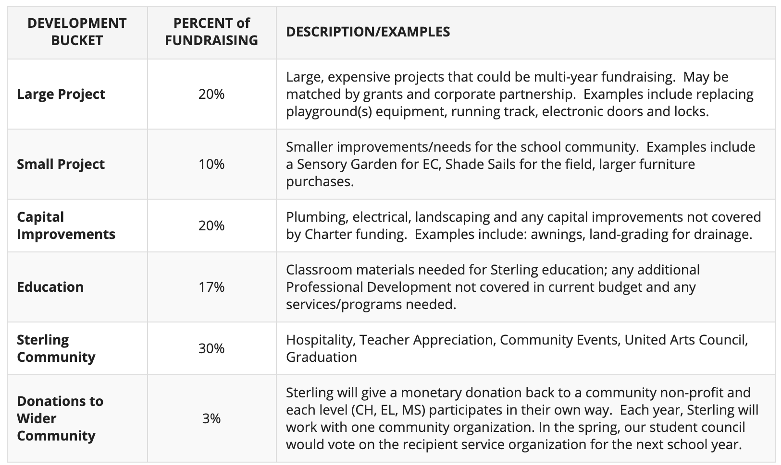

Annual Fund 2021/22 Calendar/Timeline

Grants for transportation

