RETIREMENT PLAN COMMITTEE

Annual Meeting Report

Committee Actions:

Retirement Plan Committee recommends the Board approve the recommended change to the portfolio

Minutes from May 10, 2022 Meeting:

Attendance and Call To Order
(Virtual via Google Meet)
Chair: Kim Elliott
Board Members:
Others: Christopher Nordlund, Kadedra Warren-Jones, Betty Warren, James Stout, Todd Fisher, Denise Kimball
Meeting was called to order at 10:00.

Overview by our fund managers
Chris and Kadedra presented materials for discussion by the committee.
- Funds are doing well
- 57 participants for $5,612,062 (participation rates need to be verified)
- $647 fee per participant
- Stay the course through this low market
- They recommended a change based on their scoring system

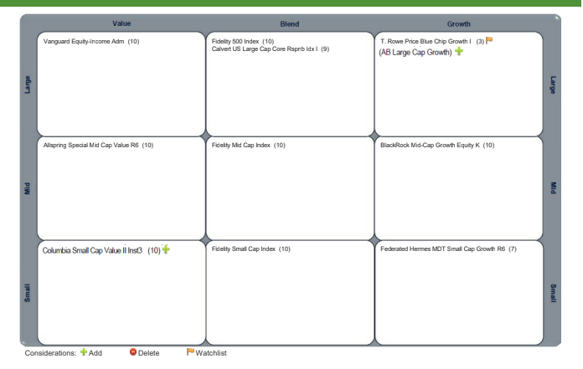
Materials included.

Closure and Next Steps:
Meeting was adjourned at 11:00 pm.
FOLLOW UP ACTIONS
Ask another staff to participate with James’s departure
Next Meeting - TBD

